*For More Visit* [*www.tekartlearning.com*](http://www.tekartlearning.com/)



5

**Name:**

**School:**

**©** [**www.tekartlearning.com**](https://www.tekartlearning.com/) **Page 1**

PUBLISHED BY TEKART LEARNING

**Year:**

*Published by Tekart Learning*

*For More Visit* [*www.tekartlearning.com*](http://www.tekartlearning.com/)

*Table of Contents*

PAPER 1 3

PAPER 2 14

PAPER 3 25

PAPER 4 35

PAPER 5 44

PAPER 6 55

PAPER 7 65

PAPER 8 74

PAPER 9 85

PAPER 10 96

PAPER 11 105

PAPER 12 115

For more Booklets of this kind, Visit [www.tekartlearning .com](http://www.tekartlearning.com/) or call +256754895241

|  |
| --- |
| **PAPER 1** |
| **SECTION A:**   1. Name any **one** non-living thing found in a garden. 2. Why does oil settle at the top when mixed with water? 3. Why are babies given **BCG** vaccine? 4. How do school children contribute to poor sanitation at school? 5. Give **one** importance of wearing shoes when moving outside the house.   **The diagram below shows a bottle with soda in it.**  space   1. Why is a space left in the above bottle? 2. Write any **one** activity that can reduce breeding of mosquitoes at home. 3. Why do bees swarm? 4. How do vegetable farmers benefit from keeping poultry? |

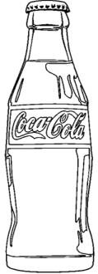

# The diagram below shows an experiment on germination.



**Healthy seeds Ice**

Why would the seeds in the experiment fail to germinate after one week?

1. How are canine teeth useful to lions?
2. Give any **one** example of a perennial crop.
3. Name any **one** fuel commonly used at home.
4. Give the use of a sting to a wasp.
5. Of what importance are health parades in a school?
6. Why is mercury a better liquid to use in a clinical thermometer?
7. An object has a mass of 10g and its volume is 10cm3. Find its density.

# The diagram below shows a first aid material. Use it to answer question 18.



1. How is the above material useful to first aiders?
2. Write any **one** way of managing drought in an area.
3. In which **one** way can shadows be of use to people?
4. How is cassava propagated?
5. Name **one** wingless insect in the environment.
6. What is the use of a vacuum flask at home?
7. Why should medicine be kept out of reach of children?
8. Name any **one** material which can easily dissolve in water.
9. State any **one** way of controlling diseases in rabbits.
10. How can boiled water in a container be protected from contamination?
11. Give the importance of a balanced diet to people.

# In the space below, draw a fibrous root system.

1. Identify any **one** sign of a dehydrated child.
2. Why does a chameleon change colour according to its surroundings?
3. Write down any **one** type of energy you know.
4. How are termites dangerous to maize farmers?
5. Name any **one** cereal crop grown in Uganda.
6. Which instrument is used to measure the amount of rainfall received in an area?
7. Besides food, mention any other basic need of people.
8. Why is it important for us to regularly spread our beddings under the sun?
9. How are the gills of fish similar to spiracles of insects?
10. Name **one** organism that reproduces by means of spores.
11. State any **one** way a mother at home can separate orange seeds from the juice.

# SECTION B:

1. Germs are organisms that cause diseases.
   1. Name any **two** examples of germs in our environment.
3. 1. Write **two** ways of controlling the spread of germs in the community.

# C:\Users\Deputy 1\Desktop\images\panga.pngThe diagram below shows a garden tool. Use it to answer the questions below.

* 1. Give the use of the garden tool above to people.
  2. Write any **two** ways of caring for the tool above.

2. 1. What is the danger of playing with the above tool?
3. (a) Name any **one** example of the following types of crops.
4. Root tubers
5. Stem tubers
6. Name any **one** disease that attacks root tubers.
7. State any **one** way in which farmers can control the disease named in (b) above.

# Complete the table below by filling in correctly.

|  |  |
| --- | --- |
| **Body organ** | **Function** |
|  | filters blood |
| Heart |  |
|  | stores information |
| Liver |  |

1. (a) Which component of soil is formed by decomposition?
2. Why is sand soil not the best for plant growth?

**sunlight**

**water + carbondioxide**

**starch + oxygen**

**chlorophyll**

1. Give **one** difference between clay soil and sand soil.
2. Identify any **one** way farmers care for their soil.

# The illustration below shows a plant process. Use it to answer question that follow.

* 1. Name the process shown above.
  2. Identify any **one** raw material needed for the above process to take

place.

* 1. Why does the above process mostly take place during day time?
  2. How do animals benefit from the process above?

1. (a) How many teeth has a normal adult person?
2. Give the function of the following types of teeth;
3. molars
4. Incisors
5. Apart from tooth decay, give **one** other danger of failing to brush teeth regularly.
6. (a) Name any **two** plants that give us proteins. (i)

(ii)

1. How are proteins useful in our bodies?
2. Which health problem is caused by lack of proteins in one’s diet?

# The diagram below shows changes in stages of matter. Use it to answer the following questions.

**B**

**sublimation**

# evaporation

**A**

**C**

**D**

* 1. Identify the states of matter marked **B** and **C**.

1. B
2. C
   1. Which physical process is represented by letter **D** on the diagram above?
   2. Put letter **F** on one stage of the arrow above which represents freezing.
3. (a) What is immunity?
4. Give any **two** ways in which a baby may get immunity. (i)

(ii)

1. What problem will a person with very low immunity face?
2. (a) Write any **two** ways insects spread diseases to people. (i)

(ii)

1. Name the vector involved in the 4Fs.
2. Identify the part of the human body which is involved in the 4Fs chain.
3. A basket and a mingling stick are some of the materials used at home.
   1. Name the material used to make a mingling stick.
   2. Name any **one** food stuff that is prepared using a mingling stick.
   3. Give any **one** use of a basket at home.
   4. Why do people make items like those above at home?
4. (a) Where in the alimentary canal does digestion of food begin?
5. Name the enzyme found in saliva.
6. State any **two** ways of maintaining proper functioning of the digestive system.

(i)

(ii)

1. (a) What is poultry keeping?
2. Give any **two** importance of poultry keeping to people. (i)

(ii)

1. State any **one** reason why some people in Uganda do not keep poultry.

# The diagram below shows a soil profile. Use it to answer questions that follow.



**A**

# B C

**D**

* 1. Name the layer marked **B** and **D**.

# A B

* 1. Why is layer **A** the best for plant growth?
  2. Give any **one** area where a soil profile can be observed in our environment.

|  |
| --- |
| **PAPER 2** |
| **SECTION A.**  **(40 marks)**   1. Give any **one** infant immunisable disease. 2. What is the use of earthworms in the soil? 3. In which way are teeth useful during digestion of food? 4. Which type of seeds undergoes epigeal germination?   **The diagram below shows a plant.**  **S**   1. Of what use is structure marked **S** to the plant? 2. Why does sand soil easily lose water? 3. Give any **one** advantage of weeding to farmers. 4. How can you help in saving electricity at home and school? 5. Why is a mosquito grouped under living things? 6. In which **one** way can you help to improve soil fertility? |

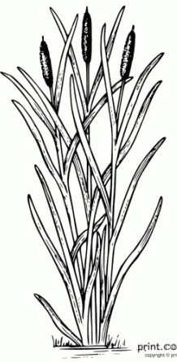

**The diagram below shows the head of a bird.**



1. By use of an arrow, show the wattle.
2. How do plants like mangoes reduce their rate of transpiration during the dry season?
3. Why is a shed put at the top of a nursery bed?
4. Name the human body organ where urine is stored before it is removed from the body.
5. Why is massive cutting down of trees dangerous to our environment?
6. Why would you advise poultry farmers using free range not to live near forests?
7. Give any **one** danger you may get for failing to wash your clothes.
8. In which **one** way can you help in controlling diarrhea at home?

**The diagram below shows a kettle with boiling water.**



**K**

1. Name the substance labeled **K**.
2. Which form of energy leads to formation of substance **K**?
3. Name any **one** disease spread by a vector that feeds on faeces.
4. Give **one** danger of polio to infants.
5. How do children get infected with worms?
6. Name any **one** type of poultry.
7. **Calculate the volume of the figure below.**

**3cm 2cm**

**4cm**

1. Why do people eat food?
2. Why are people discouraged from carelessly playing with razor blades?
3. Give any **one** natural change in the environment.
4. **In the space below, draw a whole bean seed and show the seed coat.**
5. How can you separate passion fruit juice from its seeds?
6. Name the kind of honey bee commonly found near flowers.
7. Why is it dangerous to keep poison in open places at home?
8. How do farmers care for their crops during drought?
9. **Draw the item in which rubbish is disposed in the classroom.**
10. Give any **one** advantage of keeping records to farmers.
11. How do farmers control crop pests in their gardens?
12. In which **one** way can children and their teachers use shadows in their environment.
13. In which way is a nuclear family different from an extended family.
14. How can crop farmers make good use of wind?
15. Why do animals make movements?

**SECTION B**

* 1. Name any **two** examples of domestic animals.

b) Give any **two** insects eaten by people.

3. 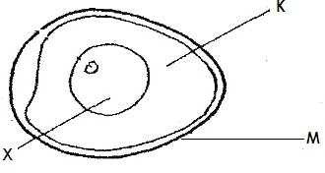**The diagram below shows internal parts of an egg. Use it to answer questions that follow.**
   1. Name the part labeled **K** and **X**

**K X**

* 1. By use of an arrow ( ) and letter **P**, show the part that develops into a chick.
  2. How is structure labelled **M** useful to poultry farmers?
  3. Identify any **two** breeds of rabbits

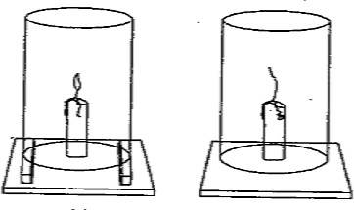




1. Name any **one** disease that affects the above animals.
2. How do farmers control rabbit diseases?
3. **Re-arrange the following sentences to describe the order (steps) involved in rain formation.**
   1. The nimbus clouds become heavy and fall as rain.
   2. Evaporation and transpiration takes place.
   3. Water vapour rises up and condenses to form nimbus clouds.
   4. The sun heats water in lakes and the vegetation.

1.

2.

3.

4. 45.**The diagram below shows an experiment which was carried out by P.3**

**pupil’s. Use it to answer questions that follow.**

**glass**

**X Y Z**

1. Which component of air supports the process in **X**?
2. Why did the candle continue burning in **Y**?

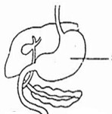

1. Why did the candle stop burning as shown in **Z**?
2. What does the above experiment show about air?
3. a) Write **ORS** in full.
4. Mention **one** solute used in making of **ORS**.
5. How is **ORS** useful to a person suffering from diarrhea?
6. Why is it important to wash hands before preparing **ORS** locally?
7. a) What is photosynthesis?
8. Name any **one** raw material needed by plants to carry out photosynthesis.
9. Write the food made by plants during photosynthesis.
10. Name the gas released by plants during photosynthesis.
11. **The diagram below shows parts of the human digestive system.**

**E**

**F G**

1. Name the parts labelled **G** and **E**.

**G E**

1. In which way is part **F** useful during digestion?
2. How can you improve on the normal functioning of your digestive system?
3. Mention any **two** items found in a first aid box.
4. Why are causalities taken to hospitals or health centres?
5. How can you assist your friend who has fallen in a pit latrine?
6. **The table below is a weather chart. Use it to answer questions that follow.**

|  |  |
| --- | --- |
| **A** | **B** |
| **C**  Description: Related image | **D** |

1. 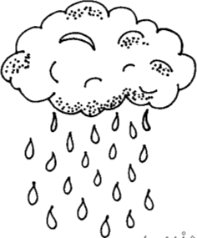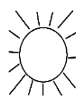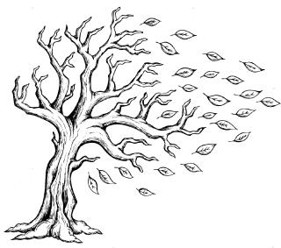Write **one** crop farming activity that may be carried out in conditions **A** and **C**

above.

1. **A**
2. **C**

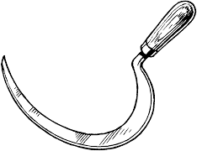

1. Which weather condition is suitable for winnowing?

_

1. Give the advantage of weather condition **D** to our environment.
2. **The diagram below shows a garden tool.**
3. Identify the garden tool shown above.
4. How is the above garden tool useful to farmers?
5. How do you care for such garden tools at home?

8. **Match the following vectors to the diseases they spread correctly.**

Vector disease

Tsetse fly plague

Housefly malaria

Female anopheles mosquito sleeping sickness

Rat fleas bilharzias

Cholera

* 1. Tsetse fly
  2. Housefly
  3. Female anopheles mosquito
  4. Rat fleas

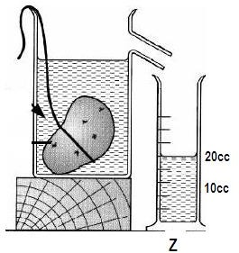

53.a) Write any **one** food stuff rich in carbohydrates.

1. Which deficiency disease can a child suffer from if he / she lacks enough carbohydrates.
2. Apart from carbohydrates, name other **two** food values required in our bodies.

54.a) What is soil erosion?

1. Mention any **one** cause of soil erosion.
2. How can erosion be controlled in the following areas?
3. school compound
4. a garden on a hilly land
5. **The diagram below shows a method used in measuring objects.**
   1. Which kind of objects are measured using the method shown above?
   2. Name container marked **Z**.
   3. If the stone has a density of 3g/cc. calculate its mass **(2 marks)**

|  |
| --- |
| **PAPER 3** |
| **SECTION A.**   1. Name the body organ affected by trachoma. 2. What happens to a piece of iron when it gets into contact with water and oxygen? 3. Which parts of a rabbit would you hold when carrying it? 4. Give any **one** role of a grandmother in an extended family. 5. How are flowers useful to plants? 6. Name any **one** area at home that needs to be kept clean. 7. **The diagram below shows a bean seed.**   **Y**  Name part **y**.   1. Identify any **one** way in which we can control and prevent common diseases at home. 2. Give any **one** example of first aid. 3. How do plants with weak stems climb others? |

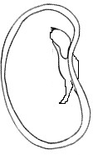

1. Give **one** example of a protective food.
2. State **one** way you can care for your teeth.
3. How is a worker bee useful in a hive?
4. Give any **one** advantage of castration in animal husbandry.
5. Convert 400C into Fahrenheit scale.
6. How is the equipment below useful in promoting personal hygiene?
7. Give any **one** sign of a dehydrated person.
8. State the importance of a compost pit at home.
9. Why is it advisable to keep drugs out of reach of children?
10. State the importance of hydrochloric acid during digestion.
11. In the space below, draw one item made from clay soil.
12. How can a P.5 pupil make use of banana fibres?
13. Name the system of keeping poultry which is most suitable for commercial purposes.
14. Write **one** activity done by children to promote sanitation in a classroom.
15. What happens to salt when put in water?
16. State any **one** way of caring for a simple tree planting project at home.
17. Name the pest whose habitat is an anthill.
18. Why do seeds fail to germinate when put in very cold conditions?
19. Why are people who make bricks encouraged to feed on foods rich in carbohydrates?

## Identify the type of hutch below.



1. Why are motor cyclists encouraged to wear helmets?
2. Why is it dangerous to harvest honey using fire?
3. Identify the element of weather used to fly a kite.
4. State any **one** advantage of breast feeding to a mother.
5. How is diesel important in our homes?
6. Name **one** fungi that people can eat as food.
7. Write **one** principle of Primary Health Care.
8. Why are roots of plants such as cassava swollen?
9. Why is deforestation dangerous to soil?

## The diagram below shows a cooking stove. Use it to answer questions 40.

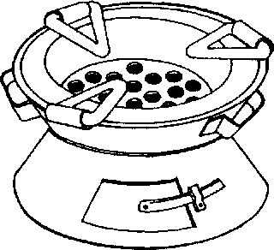

1. Name the kind of fuel used in the above stove.

## SECTION B:

1. (a) Apart from bedbugs, name any other common insect vectors at home.
2. How does a bedbug protect itself?
3. Give any **one** activity done at home to control insect vectors?
4. (a) Name any **one** staple food in your community.
5. Give **two** ways in which food can get contaminated.

8. State any **one** way in which you can conserve the food in (a) above.
9. (a) Apart from floods, mention **two** other natural changes in the environment.
10. Give **one** danger of floods in the environment.

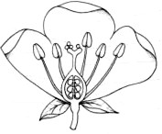

1. State **one** way of managing floods in the environment.

## Match the following body organs with their functions correctly. Organ Function

Liver pumps blood

Kidney exchange of gases

Heart produces bile

Lungs filters blood

1. Liver
2. Kidney
3. Heart
4. Lungs

## The diagram below shows a flower. Use it to answer question 45.

**X**

## Z

**Q**

## R

1. (a) Name the parts marked **X** and **Q**.

## X Q

(b) How are the following parts useful to the flower?

## Z

1. **R**
2. (a) Name the germ that causes AIDS.
3. Identify **one** cultural practice that is likely to spread AIDS.
4. Give **one** effect of AIDS to a family.
5. State the best way a P.5 pupil can avoid getting AIDS.
6. (a) What is immunity?
7. Identify **one** danger of not immunizing babies.
8. Name the vaccine given against Tetanus to the following groups of people.
9. Babies
10. Pregnant women
11. (a) State **two** physical changes that take place in the presence of heat. (i)

(ii)

1. State **one** characteristic of a chemical change.
2. Give **one** example of a biological change in plants.

## A P.5 class carried out the experiment below. Study and use it to answer question no. 49.

**40cc 30cc 20cc 10cc**

**40cc 30cc 20cc 10cc**

**Cylinder containing a stone Stone removed**



1. (a) Name the method of finding volume used above.
2. What is the volume of the stone?
3. Find the density of the stone if its mass is 30g. **(2 marks)**
4. (a) Which property of air is demonstrated when a balloon is inflated?
5. Give a reason why such a balloon will burst if left under sunshine for some time.
6. Identify the component of air which;
7. supports burning
8. is necessary for photosynthesis

**The diagram below shows a local item used in preparation of food. Use it to answer question 51.**

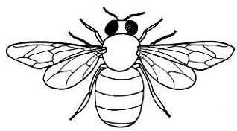

# A

**B**

1. (a) Name part **B**.
2. Name **two** food stuffs that can be prepared in the above item.

5. Why should the device above be clean before using it?
6. (a) Apart from chinchilla rabbits, mention **two** other exotic breeds of rabbits.
7. Give **one** reason why farmers keep rabbits.
8. Identify the rabbit disease which can also affect human beings.

## The diagram below shows an insect. Use it to answer question 53.

**Y**

# Z

## X

1. (a) Name part marked **X**.
2. State the function of part marked **Z** to the insect.
3. Give any **two** characteristics of the above insect.

## Complete the table below correctly.

|  |  |  |
| --- | --- | --- |
| **Garden tool** | **Name** | **Function** |
|  |  | Collecting harvested crops. |
|  | sickle | Harvesting cereals. |
|  |  | Used to plant in straight lines. |
|  | hoe |  |

1. (a) Apart from cuts, give any **two** common accidents at home.

(b) Write **two** materials that can be used to give first aid for simple cuts.



|  |
| --- |
| **PAPER 4** |
| **SECTION A.**   1. Name any **one** type of poultry you know. 2. Why is loam soil the best for crop growing? 3. Why are bees said to be social insects? 4. Give any **one** human activity commonly done in a lake. 5. Give the importance of proper sanitation. 6. Calculate the density of an Irish potato whose mass is 20g with a volume of 5cc. 7. Write any **one** function of the liver in the human body. 8. How is a Child Health Card useful to a parent? 9. Give any **one** danger of poor personal hygiene to an individual. 10. Identify the property of air shown in the diagram.   **glass**  **Air bubbles water** |



1. How can farmers increase on the number of eggs in the layers?
2. Write any **one** part of the human body commonly cleaned using a handkerchief.
3. Why does a nail sink in water and yet a leaf floats?
4. Name any **one** example of a seed from which cooking oil is made.
5. What is the importance of the structure labeled **X** in the modern bee hive below? Brood chamber **X**

Honey chamber

1. Why is it not advisable to put on a sweater during very hot weather?
2. Why should babies be given plenty of foods rich in proteins?
3. Give **one** importance of water to seeds during germination.
4. Write any **one** danger of too much rainfall to farmers.
5. In the space provided below draw the type of tooth used for cutting food.
6. How is the feeding of a tape worm different from that of a hook worm?
7. Which major human body organ filters blood?
8. Insects have different uses to people. Give **one** example of an insect that is eaten by people in Uganda.
9. Name the cloud which is a sign of rainfall.
10. Pests are organisms that destroy our crops. Describe any **one** way farmers can control pests on their farms.
11. Give the main function of leaves to plants.
12. Name any **one** component of soil that can grow, feed and move.
13. Of what use is a fire extinguisher in a school?
14. In which weather would you be encouraged to wear either a cap or sunglasses?
15. Identify any **one** artificial source of energy in our environment.
16. Describe any **one** way in which food can get contaminated at home.
17. Peter has a water pond near his home. How does the introduction of fish in that pond control the spread of malaria?
18. Draw a diagram showing epigeal germination in the space provided.
19. Write HIV in full.
20. The **5H** stands for **Happiness , Health, Hospitality, Habit and Hunger**. What does the word **Health** mean in the **5H**?
21. Give the importance of physical exercise to the body.
22. Identify any **one** breeding place of germs in our environment.
23. It is important for children to get immunization. Give any**one** place where children are taken for immunization.
24. ORS is for patients who are becoming dehydrated. What is dehydration?

**The diagram below shows a root of a soya bean. Use it to answer question number 40.**

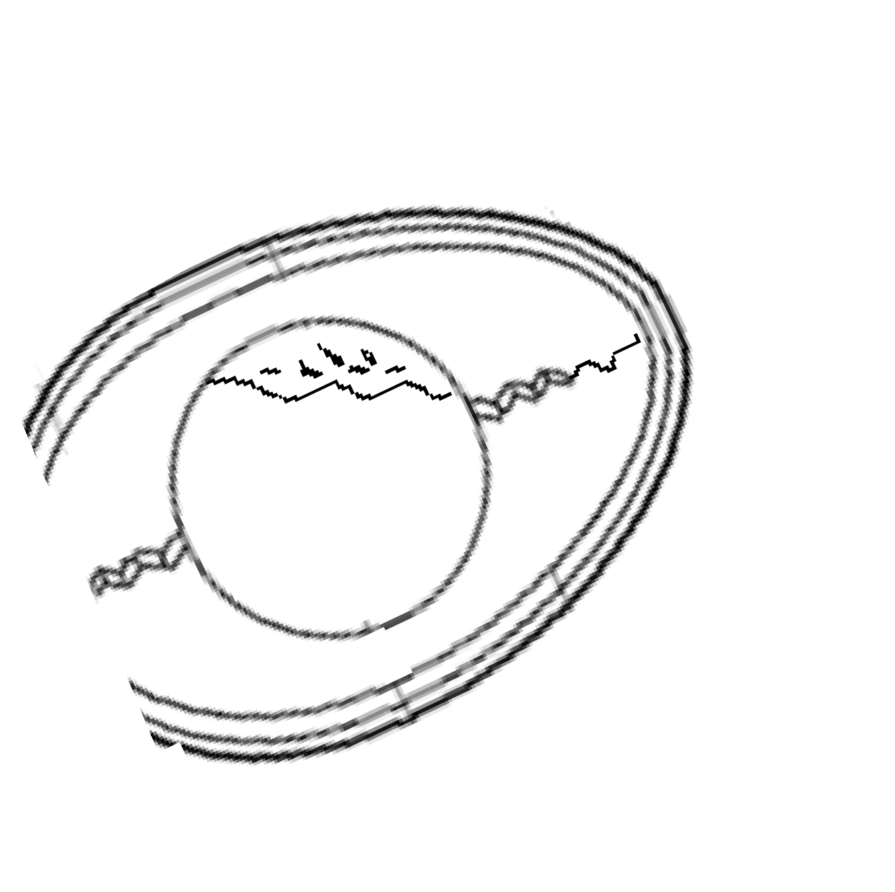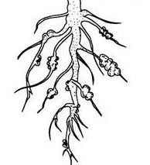

# N

1. Name what is stored / found in structure **N**.

**SECTION B**

1. **The diagram below shows an egg. Use it to answer the questions below.**

# T

**R**

* 1. Name part **R**.
  2. Give the use of the part marked with letter **T**.
  3. With the help of an arrow, indicate the part which is porous.
  4. What animal at home gives us the product above?

1. a) Give any **one** reason why some families in Uganda may not have enough food.
   * 1. State any **one** danger of not having enough food in a family.
     2. Write down any **two** places / sources where people get food for the family.

4. a) How are the following types of bees useful in a hive?
5. Drone bees
6. Female sterile bee _

b) Describe any **two** ways people may care for insects such as bees.

3. a) Name any **one** breed of rabbits.
4. Give any **two** reasons for keeping rabbits.

7. Write any **one** way of caring for rabbits.
8. a) Write any **two** raw materials green plants use to make food.

11. How is chlorophyll useful during photosynthesis?
12. Identify the by-product of photosynthesis that is used by animals to produce energy.
13. a) How are the crops below propagated?
14. Banana
15. cassava
16. Describe **one** advantage of the above propagation methods over the use of seeds.
17. Name **one** crop that is first planted in a nursery bed before transplanting.
18. a) Give any **one** cause of dehydration.
19. Write **two** signs of dehydration.

22. What treatment can you give to a dehydrated person?

## Match the vectors to the diseases they spread correctly.

female anopheles mosquito bilharzia

housefly malaria

tsetesfly elephantiasis

fresh water snails trachoma sleeping sickness

1. female anopheles mosquito
2. housefly
3. tsetsefly
4. fresh water snails
5. a) How are the following places important in our communities?
6. hospitals
7. markets
8. Write any **one** person who works in a hospital.
9. Give any **one** reason why people are taken to hospital.
10. a) Name the types of soil characterized by ;
11. rough and large particles
12. smooth , slippery and powdery particles
13. Give any **one** special thing that makes loam soil the best for growing crops.
14. Write any **one** danger of soil erosion.
15. a) Write any **two** natural changes / problems that can displace people from their villages.

b) Apart from displacing people, give **two** other dangers of natural changes.

3. a) Name the type of animals that mostly live in forests and bushy areas.
4. Of what use are those animals to people?

7. How can the above animals be protected?
8. a) Why is cholera grouped under communicable diseases?
9. Apart from cholera, give **two** other communicable diseases.

12. Give any **one** way of controlling cholera in our homes.

## The picture below shows a box.



* 1. Identify the box shown above.
  2. Which group of people use the box shown above?
  3. Write any **two** items found in the box shown above.



## The diagram below shows a method of finding volume of an object. Use it to answer the questions below.

**A**

**Stone**

**C**

20cc

15cc

10cc 5cc

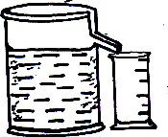

* 1. Name the instruments marked **A** and **C**.

1. **C** 
   1. Name the method of finding the volume of objects in the diagram above?
   2. What does the volume of the water displaced by the stone equal to?

|  |
| --- |
| **PAPER 5** |
| 1. Name the type of soil with a texture of rough and large particles. 2. State any **one** way of keeping our bodies clean. 3. A part from cows, give **one** other domestic animal that provides people with milk. 4. At what age is Hep B vaccine given to a baby?   **The diagram below shows a human tooth.**   1. Give the role of the above tooth during digestion. 2. Write any **one PIASCY** message that can be displayed in a school compound. 3. **The diagram below shows a basket.**   C:\Users\User 2\Desktop\images.png  Give any **one** use of the above garden tool to a farmer. |

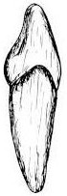

1. How is tatooing dangerous to an individual as a cultural practice?

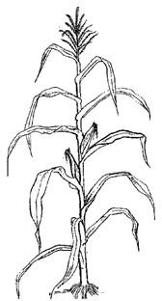

1. **The diagram below shows a maize plant.**

# J

Name the part labeled **J**.

1. Write any **one** use of keeping records on a farm.
2. Give any **one** role of relatives in an extended family.
3. What is the use of coffee husks in a poultry house?
4. Write down any **one** type of chicken.
5. In the space below, draw a playing tool that uses wind to work.
6. Why must some casualties be taken to hospital after being given first aid?



1. How can you prevent bees from swarming?

## The diagram below shows a plant.

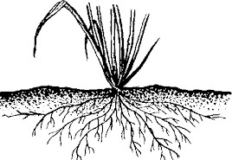

1. Name the root system shown above.
2. Why do people plant trees in their compounds at home?
3. Give the standard unit for measuring weight.
4. State the use of latrines at home.
5. Identify any **one** food stuff rich in vitamin C.

## The diagram below shows a practice carried out in poultry.

Why do poultry farmers carry out the above practice?

1. State the use of flowers to plants.
2. Name any domestic animal whose skin has hair/fur.
3. Give any **one** way people use soil as a resource.
4. Write any **one** man made change in our environment.
5. How can you tell that a plant has been attacked by pests and diseases?
6. A potter is a very important parson in our community. Name any **one** raw material he uses to do his work.
7. In the space below, draw a first aid box.
8. Why is gardening important in a home?
9. Name any **one** accident that can happen in the kitchen.
10. State any **one** way of caring for **HIV/AIDS** patients.
11. Name the plant structures that take in water and other nutrients.

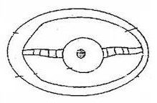

1. Write any **one** way through which soil is formed?

35 What is poaching in science?

1. Why are tsetse flies grouped under insects?
2. Name **one** activity that promotes cleanliness of the school compound.
3. State any **one** sign of ill health in a domestic animal.
4. Name the tool being used to control pests as shown below.

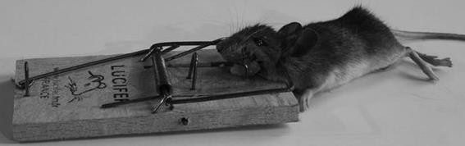

1. How does putting humps on roads help to control accidents?

## SECTION B

1. **The diagram below shows an egg. Use it to answer question 41. R**

## ~~S~~

* 1. Name part marked **R.**
  2. Give the use of part **S.**
  3. By use of letter **E** show the egg white.
  4. Name any **one** domestic animal that can lay the egg above.

1. (a) Name any **one** natural source of energy.
2. Identify any **two** uses of the following at home;
3. paraffin
4. firewood
5. Give any **one** danger of hydro electricity at school or home.
6. (a) What is dehydration?
7. Write any **two** causes of dehydration (i)

(ii)

1. Why are dehydrated people given O.R.S?
2. (a) Apart from sundrying , give any other **two** methods of preserving food at home.

(i)

(ii)

(b) Identify any **two** different foods that can be preserved by sundrying at home.








## The diagram below shows a composition of air in the environment.

**A B C D**

* 1. Identify the components of air marked **B** and **D**

## D

* 1. Which letter represents the air which supports burning?
  2. How is air marked **C** useful to plants?

1. (a) State **one** type and **one** element of weather.
2. type of weather
3. element of weather

(b) How can a farmer manage the following effects of weather?

1. Soil erosion
2. drought

## The diagram below shows a maize grain. Use it to answer question 47.

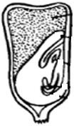

**P**

## X

**Y**

* 1. Name the parts labeled **X** and **Y**

## X P

* 1. How is part labeled **Y** useful to the embryo?
  2. Why is the above grain grouped under fruits?

## Match the following classes of food to their functions collections. Food value Function

Proteins Provides heat to the body

Carbohydrates Keep the body healthy

Vitamins Builds the body

Fats and oils gives us energy

1. Proteins
2. Carbohydrates
3. Vitamins
4. Fats and oils
5. (a) Write **two** projects which can be helpful to the school.

8. Give any **one** requirement for starting the above projects.

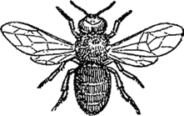

1. Give any **one** use of the above projects to a school.
2. (a) Explain what the digestive system is.
3. Name the first and last part of the Almentary canal.
4. First part
5. Last part
6. Give any **one** disorder of the digestive system.

## The diagram below shows as insect use it to answer question 51. K

**W**

## Q

* 1. Name the parts marked with **K** and **Q K**

## Q

* 1. Give any **one** use of structure **W**.
  2. State any **one** way of caring for insects.

1. (a) Write any **one** source of water in our community.
2. How is water useful to people?

5. Give any **one** material people can use in harvesting water at home.
6. (a) Name any **two** dangerous things on the road.

(b) Write any **two** people who help in controlling traffic on our roads.



## The diagram shows one of the ways of finding the volume of an irregular object.

**M**

## Irregular object

**N**

**20cc 10cc**

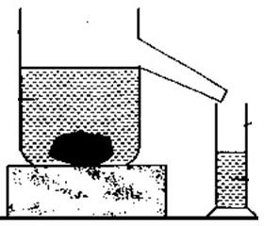

* 1. Name the container labeled **N**.
  2. Identify the method used to find the volume of an irregular object.
  3. What is the volume of the irregular object?
  4. Identify any **one** object that can float on water.

## Re – arrange the following sentences to show how rain is formed.

The evaporated water condenses to form nimbus clouds The sun heats water body.

When the clouds become heavy, they fall as rain drops. The water evaporates.



|  |
| --- |
| **PAPER 6** |
| **SECTION A:**   1. Name **one** item used for sweeping. 2. How should you care for your hair? 3. Why are people encouraged to wash hands after using the latrine? 4. **The diagram below shows parts of a leaf.**   Use an arrow and letter **K** to show the part that attaches it onto the plant.   1. How is a beak useful to birds? 2. Why should cooked food be covered? 3. **In the space below, draw a diagram showing that air exerts pressure.** 4. How does the act of mulching promote soil fertility? |



1. How do tape worms enter our body?
2. Why is a bean seed said to be a dicotyledonous seed?
3. Give any **one** effect of accidents to people.
4. Why is a mango plant said to be a perennial crop?

## The diagram below shows parts of a tooth.

**K**

Name part marked **K**.

1. How can you care for a blind person in your community?
2. Why do people prefer keeping rabbits to some animals like cows?
3. How can a primary five child differentiate sand soil from clay soil?
4. State any **one** use of a child health card to a mother.
5. Name the clouds that may indicate that it is about to rain.
6. Why do farmers carry out crop rotation?
7. Give any **one** way of spending resources wisely.

## The diagram shows a box.

Find its volume.

## Image result for a cuboid line drawing3cm

**4cm 5cm**

1. Name the body organ used for storing information and remembering
2. State **one** advantage of breast feeding to a mother.
3. Write down any **one** danger of plants.
4. Give **one** example of a wild bird.
5. How does mulching reduce soil erosion on a flat land?
6. Why is a weaning child said to be a vulnerable person?
7. How is the ileum adapted to the absorption of digested food?



1. Why does water pass through sand soil easily?
2. How is the propagation of beans different from that of cassava?
3. Name **one** element of **PHC**.
4. What scientific name is given to the house of a domestic animal that gives us security?
5. Why is carbon dioxide gas used in fire extinguishers?
6. Mention **one** way of keeping our classroom clean.
7. How does keeping fish in a pond help to control malaria in a home?

## The diagram below is of a type of thermometer. Use it to answer questions that follow.

1. Identify the type of thermometer drawn above.
2. How do most plants control transpiration in dry seasons?
3. Which name is given to substances that dissolve / disappear in liquids?

## The diagram below is of a worker bee. Use it to answer question 39 and 40.

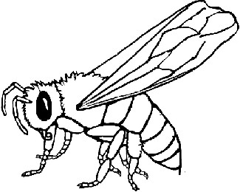

**A**

## B

1. Name the part marked with letter **B**.
2. How is part marked **A** useful to the bee?

## SECTION B

1. **The table below shows some deficiency diseases and their causes. Complete it by filling in correctly.**

|  |  |
| --- | --- |
| **Lack of** | **Deficiency disease.** |
|  | Kwashiorkor |
| Vitamin A |  |
|  | Scurvy |
| Carbohydrates |  |

1. (a) Which property of air is demonstrated when a balloon is inflated?
2. Give a reason why such a balloon will burst if left under the sun for some time.
3. Identify the component of air which;
4. Supports burning

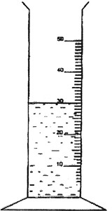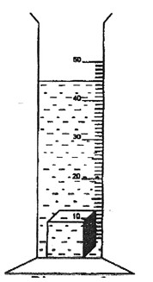

1. Is necessary for photosynthesis
2. (a) Apart from the nimbus clouds, mention other **two** types of clouds.
3. Give any **one** danger of too much rain.
4. How is leaching dangerous to crops?
5. (a) Name any **two** ecto - parasites in goats.

(b) Mention **two** ways of controlling the parasites named in (a) above.



## The diagram below shows a method of getting volume of a stone. Use it to answer questions that follow.

**String**

# A B

1. Which method of finding volume is shown in the diagrams above?
2. What is the importance of the string in the above experiment?



1. Find the volume of the stone above. **(2 marks)**
2. (a) Write **PHC** in full.
3. State any **one** principle of **PHC**.
4. Give **one** activity you can do to promote personal hygiene.
5. Give **one** way in which you can assist an elderly person.

## The diagram is part of flower. Use it to answer the following

**questions. E**

# K

1. Name parts **E** and **K E**

## K

1. State the function of part **E**.
2. How is the above part of a flower useful to bees?

## The diagram shows part of the digestive system. Use it o answer

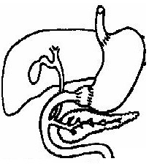

**question 48. A R**

# G

**Z**

1. Name part **A.**
2. Use **letter V** to show the part that produces gastric juice.
3. What is the function of part labelled **R** during digestion?
4. How can the above system be kept healthy?
5. (a) Write 4F’s in full.
6. Write down any **two** diseases that are spread through the 4F’s.

(i)

(ii)

1. Identify any **one** way in which you can control the spread of the diseases you have given in (b) above.
2. (a) Name **one** example of the following tuber crops.
   1. Root tubers
   2. Stem tubers
3. Mention **one** pest that destroys root tubers.
4. How can pests of tuber crops be controlled?
5. (a) Name any **two** exotic breed of rabbits.
6. Mention **one** disease which commonly attacks both rabbits and poultry.
7. Why is it advisable for rabbit farmers to keep rabbit houses clean and dry?
8. (a) Identify **one** way in which **HIV /AIDS** spreads.
9. Write **ABC** in full as used in the control of **HIV/AIDS**.
10. Mention **one** effect of **HIVAIDS** to an individual.
11. How can you care for **HIV/AIDS** patients?
12. (a) Mention any **two** insects eaten by people in your community.
    1. (ii)

(b) Give any **two** dangerous insects in the environment. (i)

* 1. (ii)

1. (a) How is a shadow formed?
2. How can shadows be helpful to people in the environment?
3. When are shadows longest?



1. Draw the shadow of the object below.
2. (a) How are the following weather instruments useful at a weather station?
   1. Rain gauge
   2. Wind vane
   3. Barometer

(b) Why is a rain gauge usually placed in an open space?

|  |
| --- |
| **PAPER 7** |
| **SECTION A. (40 Marks)**   1. Name any **one** component of the environment. 2. Give any **one** reason why people keep birds at home. 3. How are gills of a fish similar to spiracles of an insect? 4. Mention the type of feeds given to birds for egg production. 5. How are dust bins useful in a class room? 6. Why do people wash fruits like mangoes before eating them? 7. Mention any **one** advantage of planting trees in a compound. 8. Give the use of the garden tool shown below.      1. Why do insects like bees and wasps have stings? 2. Name any **one** condition necessary for seed germination. 3. In which **one** way do people control the spread of malaria in their homes? |

1. Why do parents take their children for immunization?

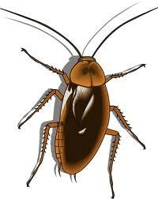

1. How is anemometer useful at a weather station?
2. Give any **one** reason why farmers mulch their garden.
3. Identify the habitat for a fish.
4. Why is a spider not considered to be an insect?
5. Write the use of splints to a first aider.
6. How can a poultry farmer improve on his/her local breeds of chicken?

## The diagram below shows a cockroach.

1. Briefly describe any **one** danger of the above insect to people.
2. Give any **one** activity you can do to keep your body clean.
3. How do dogs help in protecting our homes?
4. Mention any **one** danger of drinking unboiled water.



1. How is the rearing of bees useful to a crop farmer?
2. List down any **one** example of perennial crops grown in Uganda.
3. How does the putting of humps on roads help to control accidents on Uganda roads?
4. Why do poultry farmers debeak their birds?
5. Give any **one** danger of windy weather in our environment.
6. State the main function of the kidney in the human body.
7. What is the main source of heat and light in our environment?

**The diagram below shows part of a split bean seed.**

# M

1. Give the function of part marked **M** to the seed.
2. How is too much sunshine dangerous to a crop farmer?
3. Give any one way a poultry farmer can benefit from egg shells.
4. How does the use of soap control the spread of germs to people?

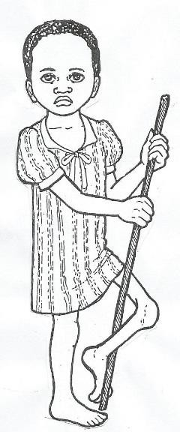

1. Give the danger of failing to brush teeth to an individual.
2. Why do mosquitoes fly from one place to another?
3. Give any **one** advantage of putting litter in a poultry house.

## Study the picture of a child shown below.

1. Name the immunisable disease that could have affected the child in the diagram above.
2. Why are vitamins grouped under protective foods?
3. How are windows useful on a house?
4. Name any **one** exotic breed of rabbits you know.

## SECTION B (60 Marks)

1. (a) What is air?
2. Name any two components of air.

5. Which component of air supports burning?
6. (a) Write O.R.S in full.
7. Why are people with diarrhoea given **ORS**?
8. What is the value of washing hands before preparing **O.R.S**?
9. Why do people first taste the **O.R.S** before giving it to the patient?
10. (a)Write any **two** common accidents at home.

(b) Describe any **two** ways in which you can care for a casualty.

(i) (ii)

1. (a) Name any **two** examples of poultry.

(b) Mention any **two** ways in which farmers care for poultry.

(i) (ii)

1. (a) Name any **one** process in plants that helps in information of rainfall.
2. Give the use of the sun during rain formation.
3. Why is too much rainfall dangerous to people?

6. (a) Name any **one** source of food in our environment.
7. Mention the food value our bodies use in producing energy.
8. To which food value do the following belong?
9. Fish
10. Bread
11. **Study the diagram below and answer questions that follow.**

# water

**P**

# glass

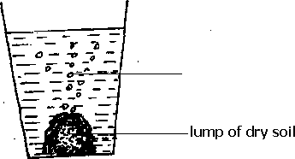

1. Which experiment is shown above?
2. Name the substance marked **P**.
3. Mention any **one** use of air in the soil.
4. Apart from air, name any other component of soil.
5. (a) What are vectors?
6. Name the vector that spreads cholera.
7. Mention **two** ways people can control vectors in their homes. (i)

(ii)

## Match animals and their products. A B

* 1. Sheep eggs
  2. Turkey wool
  3. Rabbit milk
  4. Pig fur

pork

1. Sheep
2. Turkey
3. Rabbit
4. Pig

## Study the body organs below and answer questions that follow.

|  |  |
| --- | --- |
| **A** | **B** |

1. Name the human body organs marked **A** and **B**.

## A

1. **B**
2. Give any **one** use of each of the above organs to people.

## A

1. **B**
2. (a) Write any **one** material that can be used in mulching.
3. State any **two** ways mulching is useful to a crop farmer.

6. Write any **one** disadvantage of mulching gardens.

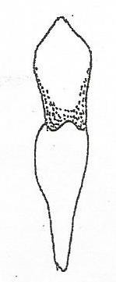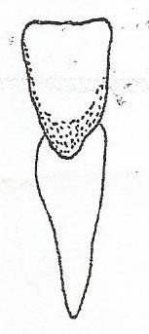

1. (a) What name is given to time taken by an egg to hatch into a chick?
2. How long do the eggs of these birds take to hatch into chicks?
3. hen
4. ducks
5. Identify any **one** factor that can fail an egg to hatch into chicks.
6. **Study the diagram below and answer questions that follow**.

# X Y

1. Name the type of teeth marked.

## X

* 1. **Y**

1. Why is tooth **x** able to carry out its function?
2. Apart from water and a tooth brush, name **one** other material used in the process of brushing teeth.
3. (a) What are pests?
4. Mention any **two** examples of pests.
5. Why do farmers put scare crows in their gardens?
6. (a) Name any **two** conditions necessary for a seed to germinate.
7. Name any **one** crop that undergoes;
   1. Epigeal germination.
   2. Hypogeal germination

|  |
| --- |
| **PAPER 8** |
| 1. Name any **one** natural component of the environment. 2. How is a broom useful at school? 3. Give any **one** use of paraffin at home. 4. Give any **one** food stuff rich in proteins. 5. Why should we wash fruits like apples before we eat them? 6. How do people in your family control the breeding of vectors? 7. Name any **one** thing at home we use and spend money on. 8. Mr. Kato’s poultry lay eggs with soft shells. What advice can you give to him?   **The diagrams below show containers found at home.**  **Jerrycan Pot**  **B**  **A**   1. Give any **one** advantage of container **A** over container **B**. |

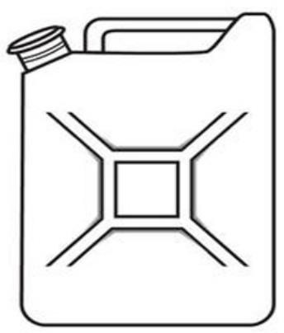



1. State any **one** importance of carrying out crop rotation.
2. How are teeth important during digestion of food?
3. Why should schools have projects like poultry keeping?
4. In the space below, draw a diagram to show a chicken drinker.
5. Name any **one** example of an intestinal worm in human beings.
6. Why are we encouraged to put on gumboots when walking in mud?

## The diagram below shows a kind of germination.

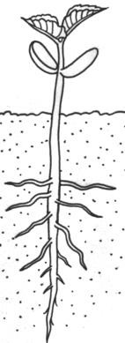

1. Name any **one** plant whose seeds undergo the above germination.
2. Identify any **one** effect of poor feeding to an individual.
3. Apart from nimbus clouds, give any other type of clouds you know.
4. Why should you cover your nose with a handkerchief or any other protective gear when sweeping a classroom?
5. Give any **one** practice that promotes good oral health.
6. What first aid can you give to your young brother who was burnt by hot tea?
7. Why is it important for every school to have a first aid kit?
8. Write **SSS** in full as used in the management of dehydration.
9. How are root crops like cassava preserved?
10. Name any **one** component of soil formed as a result of decaying.
11. Give any **one** common method of harvesting honey.
12. Identify any **one** bad farming practice which can lead to the destruction of the environment.
13. Identify any **one** indicator of poor sanitation in an area.
14. How is a child health card useful to parents?
15. State any **one** danger of using wood fuel at home.
16. Why is it important to control pests and crop diseases on a crop farm?

## The diagram below is a common activity in our community.

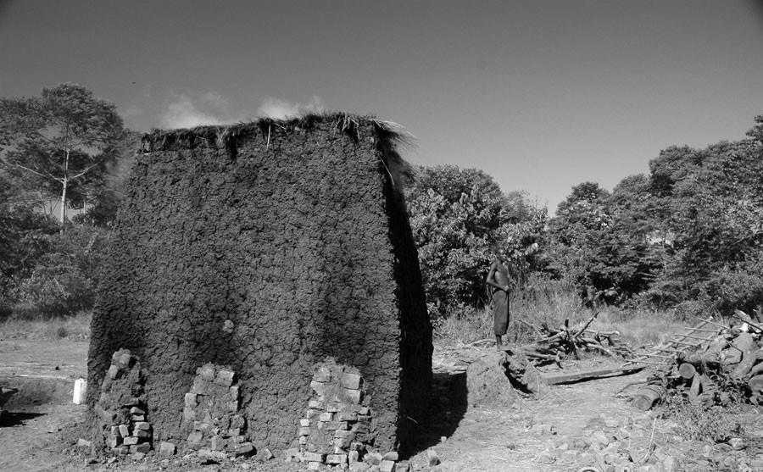

Name the building material we get from the activity above.

1. Why should sick people be taken to hospital?
2. How does heat travel through solids?
3. How is a rain gauge different from a thermometer?
4. Give any **one** way of conserving the environment.
5. Why should animal habitats be kept clean?

## The diagram below shows a type of tooth.



Name it.

## The diagram below shows a cuboid.

**3 cm**

## 4 cm

**5 cm**

Calculate its density if it has a mass of 90g.

1. Mention any **one** habit that may endanger the human liver.

## SECTION B.

1. (a) Give any **two** examples of domestic animals.
2. Name the young ones of each of the domestic animals you have given in
   1. above

(i)

(ii)

1. (a) Name any **one** type of vaccine.
   1. Write **OPV** in full.
   2. How are the following vaccines administered in the body?
2. BCG vaccine -
3. Polio vaccine -

## (a) Draw a well labelled diagram showing the property of air below.

Air has weight.

## (2 marks)

(b) Give any **one** use of the following to people.

1. air
2. water
3. (a) Give any **one** type of rabbit kept in Uganda today.
4. List down any **one** breed of rabbits kept in your community.
5. State any **two** examples of diseases which commonly attack rabbits. (i)

(ii)

1. (a) Name the germ that causes **AIDS**.
2. How does **AIDS** spread?
3. How can **AIDS** be controlled amongst school children?
4. Why is it not bad to play football with **HIV** positive patients?
5. (a) Identify any **one** source of food in the environment.
6. Give any **two** uses of food values to the body. (i)

(ii)

1. Name the vitamin that may be missing from someone’s diet if he is

suffering from Night blindness.

1. (a) How do farmers prepare their land for crop growing?
2. In the space below, draw any **one** garden tool farmers use for harvesting crops.
3. How do farmers care for their crops while in the garden?

6. **The diagrams below show an experiment performed by a primary five class.**

# A B C

**Soil**

# sample

## Soil sample



1. Identify the soil samples marked.

## A

1. **B**
2. Apart from using soil for such experiments, give any **two** other uses of soil to people.

5. (a) Convert 150C to 0F.

## (2 marks)

1. State any **one** reason why handles of iron boxes are made out of wood.
2. Why are houses in desert areas painted white on the outside?

## Re-arrange the following sentences to make the correct order of the water cycle.

1. Evaporation and transpiration take place.
2. The clouds become heavy and fall as rain.
3. The sun heats water and vegetation.
4. Condensation takes place in the sky.



9. (a) Identify any **two** objects that can float on water.
10. Why does a stone sink in water?
11. Name the element of weather that can be used to fly a kite.
12. (a) How is the stomach useful during digestion?
13. Where does digestion of food end in the human body?
14. State any **two** behaviour and habits of maintaining good working conditions of the digestive system.

(i)

(ii)

1. (a) Give any **one** importance of water.
2. Identify any **one** common source of water.
3. State any **one** way we can maintain water sources.
4. Name any **one** item people can use when harvesting water.
5. (a) Identify any **two** local materials in our environment that are used for making balls.

(i)

(ii)

1. Give any **one** use of the things we make such as balls, toys, dolls etc.
2. Why should you knead clay before using it to make pots?
3. Maso observed a mango fruit using the five senses as shown below. Fill in the missing information.

|  |  |  |
| --- | --- | --- |
| **Observation** | **Sense** | **Body structure used to observe** |
| **Smooth surface** | **touch** | **skin** |
| Fruity | smell | (i) |
| Red colour | sight | (ii) |
| Makes sound when dropped | hearing | (iii) |
| Sweet | taste | (iv) |

|  |
| --- |
| **PAPER 9** |
| **SECTION A:**   1. Name the types of soil which has the biggest particles. 2. Give **one** common example of a root tuber. 3. Which method of heat transfer enables water to boil? 4. Why should the floor of a pig sty be slanting? 5. How are the prickly hairs important to a caterpillar? 6. **Name the type of tooth shown in the diagram below.**   Image result for images of a canine tooth scientific drawing   1. How can a farmer make mating easy in sheep? 2. In the space provided below, draw a garden tool used for harvesting cereals and cutting grass for animals. |

1. Give any **one** indicator of poor sanitation of a place.

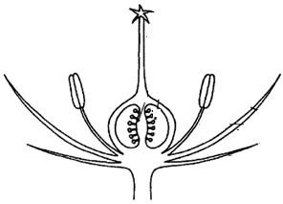

## The diagram below shows part of a flower.

**X**

Give the function of part labelled **X**.

1. Which immunisable disease is prevented by oral drops?
2. In which units do we measure the amount of rainfall received in an area?
3. Give any **one** money generating occupation of people in your subcounty.
4. State **one** way farmers can control pests and crop diseases in a garden.
5. Name **one** cereal crop.
6. What is the density of a stone that displaces 40cc of water and has a mass of 120g?
7. Which member of a nuclear family heads the family?
8. Name **one** type of poultry.
9. Give any **one** importance of the sun to plants.
10. State **one** danger of domestic animals.
11. Name any **one** locally made fuel at home.
12. How are swamps important to people in the environment?
13. Convert 860F to 0C.
14. In the space below, draw a diagram showing how molecules are arranged in a solids.
15. What injury is caused by dry heat on the human skin?
16. Name the natural material people at school can use to make balls and ropes.
17. What scientific name is given to activities carried out in order to get knowledge, skills and money?
18. Name the source from which local potters get clay for modeling / making pots.
19. Name **one** process involved in the watercycle.
20. Write down any **one** way of caring for **HIV/AIDS** patients.
21. Give any **one** effect of clouds in the environment.
22. Give any **one** use of paraffin at home.

## The diagram below shows a life cycle of a vector.

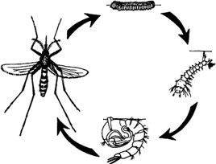

Name the vector.

1. Write down **one** danger of energy such as wind.
2. Identify any **one** breeding place of bacteria.
3. Why do farmers keep records in their farms?
4. How are shadows useful to people?
5. Why is it very important to wash hands before preparing ORS?
6. Mention **one** way of caring for a person who has taken rat poison.
7. Identify any **one** crop farming practice which retains moisture in the soil.

## SECTION B

1. (a) List down any **two** examples of wild animals.

(b) Mention the habitats of the following domestic animals.

1. domestic rabbit
2. a cow
3. (a) Mention **one** way soil is formed.
4. Give any **one** effect of harmful materials like polythene bags to soil.
5. How do farmers keep the soil fertile?
6. Why does sand soil allow much water to pass through it easily?
7. (a) Give any **two** characteristics of insects.

(b) List down any **two** dangerous insects at home.

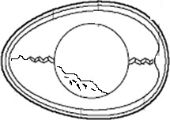





## The diagram below shows parts of an egg.

**Y**

## X

**Z**

1. Name parts marked with letter;

## X

**Z**

1. How is part marked **Y** useful to an egg?
2. What advice can you give to a poultry farmer whose birds lay eggs with soft shells?
3. (a) How are the following body organs useful in the body?
   1. Liver
   2. Kidney

(b) How do people keep their body organs in a proper working condition?

1. **The diagram below shows a method used at home to separate some mixtures.**

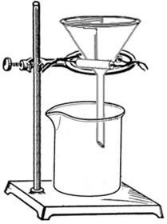

# Filter paper

**X Funnel**

# Container

**Y**

1. Name the method of separating mixtures above.
2. Name substances marked with letters;

## X Y

1. Identify any **one** mixture at home separated using the method above.

## Match items in A with those in B correctly. A B

1. Burn injury on skin caused by wet heat.
2. Fracture break or crack in a bone.
3. Scald injury on skin caused by dry heat.
4. Dislocation movement of a bone from its position at a joint.
5. Burn
6. Fracture
7. Scald
8. Dislocation

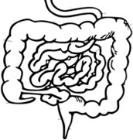

## The diagram is of part of the digestive system. Use it to answer the questions that follow.

**L**

## Z W

1. What is egestion?
2. Name part **L**.
3. State **one** role of part **W** in the digestion of food.
4. What takes place at **Z** during digestion?
5. (a) What is an accident?

(b) Give **one** safety precaution when using electricity at home.

1. Give **two** qualities of a good First Aider.

4. (a) People keep their different body parts clean in different ways. Give any

**two** ways we keep our bodies clean.

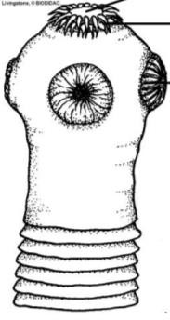




1. State any **two** dangers of not keeping your body clean.

## The diagram is part of a tapeworm.

**X**

## Y

**Z**

1. Name part **X**.
2. How is part **Y** useful to a tapeworm?
3. How do people get infected with tapeworms?
4. How can tapeworm infestation be controlled?

## The diagram shows a thermometer.

**X**

1. Name the type of thermometer shown above.
2. How is part **X** important on the above thermometer?
3. Mention **one** part of the human body where the above thermometer is placed in order to measure the body temperature.
4. Why is mercury commonly used in the thermometer above?
5. (a) What is germination?
6. Besides water, name **one** other condition necessary for seed germination.
7. How is water important during germination?
8. Give **one** factor that may fail a seed to germinate.
9. (a) What is soil erosion?
10. Mention any **two** non-living agents of soil erosion.

13. How is soil erosion dangerous to crop farmers?
14. Re-arrange the following sentences following steps of obtaining salt from a mixture of salt and sand.
15. Stir to dissolve the salt.
16. Boil the solution to dryness.
17. Put the salt and sand in a container and add water. D Filter to remove sand from the solution.

|  |
| --- |
| **PAPER 10** |
| **SECTION A.**   1. Name the component of soil formed by decomposition. 2. How can you control mosquito bites in a bed room? 3. Give **one** effect of poor feeding to an individual. 4. Apart from giving light, give **one** other form of energy given off by the sun. 5. State any **one** danger of wind.   **The diagram below shows a bean seed. Use it to answer questions that follow.**  **K**   1. Give the use of part **K** to the embryo. 2. How is a smoker useful when harvesting honey? 3. Why is it important for crop farmers to weed their gardens regularly? 4. Identify **one** way of caring for insects. 5. Why do objects weigh less in water than on land? |

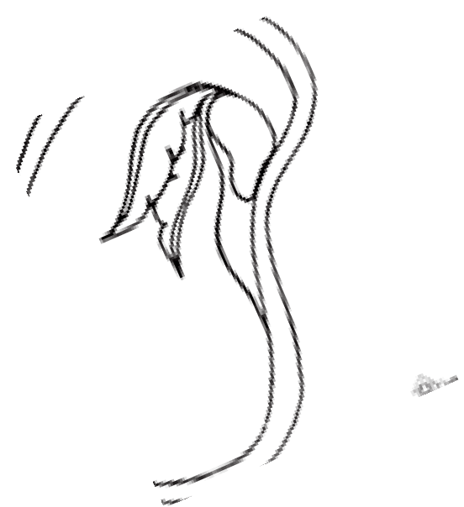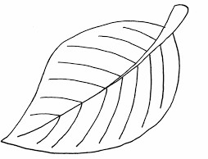

1. How is a kidney important in a human body?
2. Why is de-beaking important in poultry keeping?
3. Which disease is immunized against using OPV vaccine?
4. Which part of an insect has a similar function as the parts of the leaf labelled **X**.

**X**

1. Apart from being brightly coloured, mention **one** other way flowers can attract pollinators.
2. Why do plants shed their leaves during the dry season?
3. Identify **one** activity at home where filtration is used.
4. How can a P.5 pupil use banana fibres as a play material?
5. Write **one** message of PIASCY which prevents school children from getting HIV/AIDS.
6. How can you protect yourself from contracting HIV?
7. How is a microscope useful to a science class?

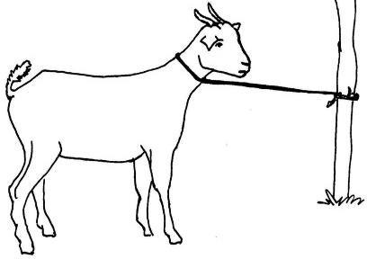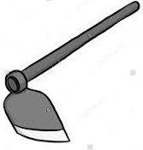

1. Write **one** building material got from a river.
2. Why do bed bugs produce a nasty smell when touched?
3. Name any **one** food crop harvested using the garden tool below.
4. Why it is dangerous to walk bare footed in dirty wet places?
5. Why is it advisable to wash our hands with soap after using a toilet?
6. How is wool useful in our daily life?
7. Which part of cabbage store food?
8. Why is it dangerous to keep many birds in a small house?
9. An object has a mass of 60gm and its volume is 30cc. Find the density of the object.

## The diagram below shows a common method of grazing goats at home. Use it to answer questions 31 and 32.

1. Name the method of grazing above.
2. Give **one** disadvantage of the method shown above.
3. State any **one** way of maintaining good oral health.
4. Write any safe way of using a road.
5. Give **one** effect of heat on matter.
6. A piece of paper and a nail where thrown from the top of a house. Which of the two objects fell on the ground first?
7. Give any **one** danger of floods in your community.
8. In the space below, draw one thing we can make from clay.
9. Why are mineral salts not digested along the alimentary canal?
10. Name any **one** device that we use to keep our bodies clean.

## SECTION B

1. (a) What is First Aid?
2. Name **two** things found in a First Aid box. (i)

(ii)

1. Why should every school have a first aid box?
2. (a) Name the fungi used in baking bread.
3. Why can’t fungi make their own food?
4. How do the following organisms reproduce?
5. Mushrooms -
6. Bacteria -

## Complete the table below correctly.

|  |  |
| --- | --- |
| **Disease** | **Vector** |
|  | water snail |
| Elephantiasis |  |
|  | infected dog |
| River blindness |  |

1. (a) What name is given to the process that enables plants to make their food?
2. Name **two** raw materials needed for the process named in (a) above.

5. Give the use of chlorophyll in the process named in (a) above.
6. (a) Name **two** vegetable crops which are first grown in a nursery bed.

(b) Give **two** ways of caring for crops in a nursery bed.

3. (a) Give **one** example of a biological change in each of the following;
   1. Plants
   2. Animals

(b) State **two** differences between a chemical and a physical change.



## The diagram below shows how diseases can be spread through the 4Fs in their order. Use it to answer question 47

**L**

**Fingers**

**Flies**

**G**

1. (a) Name the agents of the cycle marked **L** and **G**.

## L

* 1. **G**

1. Name **one** disease spread through the above cycle.
2. How can houseflies be controlled at home?

## Match the following immunisable disease with their signs correctly. Disease sign

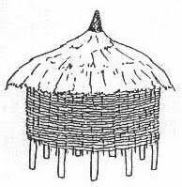

Tetanus skin rash

Diphtheria paralyzed limbs

Measles swollen neck

Polio stiff muscles

## Disease sign

1. Tetanus
2. Diphtheria
3. Measles
4. Polio

## The diagram below shows a local food store. Use it to answer question 49.

**S**

**P**

1. ( n to the food store above?

a) What name is give

1. How is part marked **S** useful on the store above?
2. Identify the importance of structure **P**.
3. Name any **one** food stuff stored in the above store.
4. (a) State any **one** way in which soil is formed.
5. Give **two** ways of keeping soil fertile.

8. State **one** human activity that may make the soil infertile.

## The diagrams below show a method of preparing a common solution at home. Use it to answer question 51.

**1 litre of drinking water**

**+ + = X**

## Y

1. (a) What name is given to the solution at **X**.

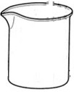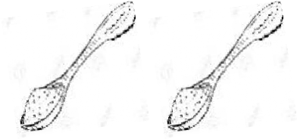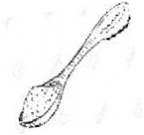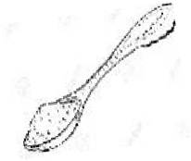

1. Name the solute labelled **Y**.
2. What is the importance of the solution above?
3. Mention **one** sign of a person supposed to be given the above solution.
4. (a) Name any **one** type of poultry.
5. Give **two** reasons why farmers rare poultry.

8. Why is deep litre system most suitable for commercial purposes?
9. (a) Give any **two** traditional ways of preserving food.

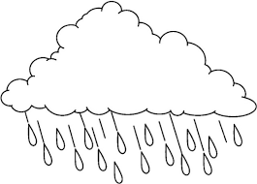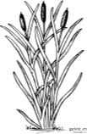




1. In which way is the preservation of sorghum similar to that of fish?
2. What is the role of sunshine during preservation?

## The diagram below shows a water cycle. Use it to answer question 54.

**sun Clouds**

**B**

**A**

**Plants**

1. (a) Which element of weather is labelled **B**?
2. Name the physical process taking place at **A**.
3. What is the role of the following in rain formation?
4. the sun
5. plants
6. (a) To which state of matter do the following belong?
   1. Milk
   2. Sand
   3. Air

(b) Name **one** substance which can belong to all the three states of matter.

|  |
| --- |
| **PAPER 11** |
| **SECTION A.**   1. Name any **one** non-living component of soil. 2. Give **one** example of a vegetable crop. 3. Why should you wash your hands before serving food to others? 4. Give any **one** item people may use to clean their bodies. 5. Give any **one** way you can reduce soil erosion in a school garden. 6. Immunity is the ability of the body to resist disease causing germs. Mention **one**   type of immunity.   1. How are nimbus clouds formed? 2. Why are we encouraged to chew food properly before swallowing it? 3. Why are petals of some flowers brightly coloured? 4. A stone has a mass of 80g and its density is 2g/cc. Find the volume of the stone. 5. Why is it a good practice to dispose human faeces in the latrine? |
|  |

1. Why should a rain gauge be placed in an open area?
2. Write “**AIDS**” in full.
3. Identify any **one** cause of accidents at home.
4. Why does sand soil allow much water to go through it easily?
5. State any **one** device that is needed when milking.
6. Why do farmers commonly harvest their crops in the dry season?
7. An extended family is a family composed of parents, their biological children and other relatives. Give **one** example of other relatives.
8. Why should you keep lights off when not needed for use?
9. Identify **one** biological method we can use to control vectors in our environment.
10. Write any **one** method of preparing meat for eating.
11. State any **one** sign of worm infection in children.
12. Give **one** use of a basket as a garden tool.

**The diagram below shows parts of an egg.**

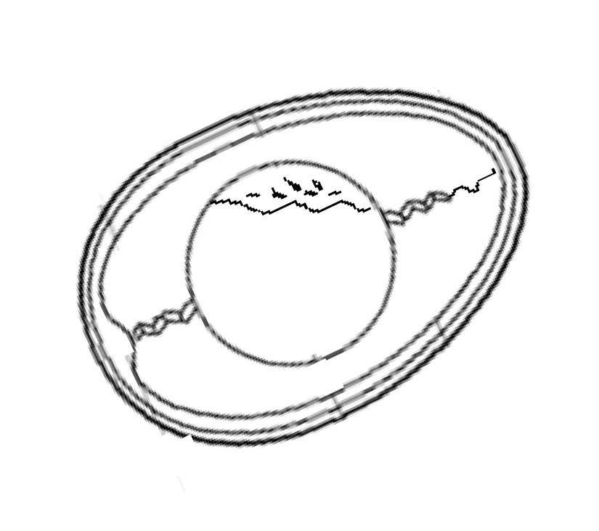

**K**

1. Name part marked **K**.
2. How is poultry keeping helpful to people?
3. Identify any **one** example of a disease which can spread as a result of poor hygiene.
4. Name any **one** playing material that can be made from banana fibres.
5. How is the liver useful during digestion of food?
6. How many teeth is the milk set made up of?
7. **In the space below, draw a garden tool used for transplanting seedlings.**
8. In which way does slashing around our homes help in controlling malaria?
9. **The diagram below shows a house.**

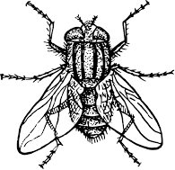

**R**

How is part labeled **R** useful to the people who stay in such a house?

1. Identify any **one** activity you can carry out to keep your bedroom clean.
2. How can we prevent accidents both at home and school?
3. What advise would you give to a friend with a bad breath?
4. In which **one** way can you prevent your crops from being damaged by pests?
5. **The diagram below shows an insect.**

By using letter **X** show the part it uses for hearing.

1. Identify any **one** way people can control and prevent cockroaches at home.
2. Give **one** way of preparing water for drinking.
3. As a crop farmer, how can you make use of grass that has been cut from a compound?

**SECTION B**

1. a) List any **two** examples of useful insects.

b) Give **two** ways of caring for insects.

3. a) Briefly explain the term crop rotation.
4. Why are legumes included in a crop rotation cycle?
5. How is crop rotation important to a farmer?

8. a) Why is it important to feed a family on a balanced diet?
9. Write any **two** food values in a balanced diet.

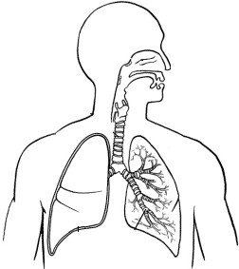


2. How can drought affect a family’s feeding in rural areas?
3. a) Give **one** example of plants that can be used as ;
   1. plant fibre
   2. medicinal plant

b) Give **two** examples of wood fuel commonly used at home.

3. a) What are enzymes?
4. Name **one** enzyme found in the following parts of the digestive system.
5. mouth
6. duodenum
7. State **one** disorder of the digestive system.
8. **The diagram below shows the positions of some human body organs.**

**Y**

**X**

1. Name the organs marked;
2. **X** -
3. **Y** -
4. How is the function of **Y** different from that of **X**?
5. How can you keep the organ marked **X** in good working condition?
6. a) Apart from **B.C.G** vaccine , give other **two** vaccines administered to babies.
7. Why is **B.C.G** vaccine administered at birth?
8. What advice can you give to Mr. Lutu whose children are suffering from measles?
9. a) Identify any **two** harmful materials of soil.
10. Give **one** importance of a compost pile in a home of a farmer.
11. State **one** disadvantage of artificial fertilizers.
12. a) Give **two** examples of worms which commonly attack people.

b) Name any **two** examples of ecto-parasites which depend on people.

3. a) Give the meaning of the term communicable diseases.
4. How is diarrhea as a communicable disease spread?
5. Why is ORS given to patients who have diarrhoeal diseases?
6. Why are school children advised to abstain from sex?
7. Sanitation is the general cleanliness of the environment.
8. Mention any **two** ways children keep the school compound clean.

11. How does smoking improve on the cleanliness of a pit latrine?
12. Give **one** advantage of a VIP latrine over an ordinary Pit latrine.
13. **Match the following nutritional diseases to causes.**

**Disease Cause**

* 1. Kwashiorkor - Lack of enough vitamin C.
  2. Scurvy - Lack of enough iron.
  3. Rickets - Lack of enough proteins.
  4. Anaemia - Lack of enough vitamin D.

1. Kwashiorkor
2. Scurvy
3. Rickets
4. Anaemia
5. a) List down any **two** breeds of rabbits kept in Uganda.
6. How do rabbit farmers control the spread of rabbit diseases on their farms?
7. Why do some farmers prefer keeping rabbits to other animals like cows?
8. a) Mention any **one** man-made change in the environment.
9. How are floods dangerous in the environment?
10. Which type of weather enables farmers to winnow their seeds?
11. Why do people use umbrellas when walking under rain?
12. **The diagram below shows a food stuff.**

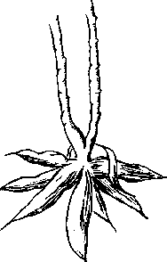

1. Name the food stuff shown above
2. How is the food stuff above harvested?
3. Give any **one** way in which the food stuff above can be prepared for eating.
4. State **one** way the food stuff above can be preserved for along time.

|  |
| --- |
| **PAPER 12** |
| **SECTION A: 40 MARKS**   1. Give any one state of matter. 2. State any one advantage of mulching. 3. Why is immunization important in our community? 4. Mention one type of digestion. 5. How can poultry farmers improve on the quality of local breeds of chicken? 6. State one way of managing sunny weather. 7. Why are grasshoppers called solitary insects? 8. Identify one example of fungi used in baking. 9. Why is it advisable to eat well cooked meat? 10. How important is a dustbin in a P.5 classroom? 11. What is weather? |

# Use the diagram below to answer the question 12.

1. How is the above part of plant useful to people?
2. Apart from the queen bee, name any other type of bees in a beehive.
3. State one difference between mass and weight.
4. Give one practice that can prevent tooth decay.
5. Why is a maize grain called a fruit but not a seed?
6. How do bacteria reproduce?
7. Name the method used to separate small stones mixed with rice.
8. State the reason why we give first aid to a causality.
9. Why a sugarcane regarded as a stem tuber?
10. Mention one item used to clean our ears.
11. How can strong wind be controlled around the school?
12. Identify the function of the kidney to the body.
13. Name the domestic animal that controls pests at home.

# Use the diagram below to answer the questions that follow.

1. 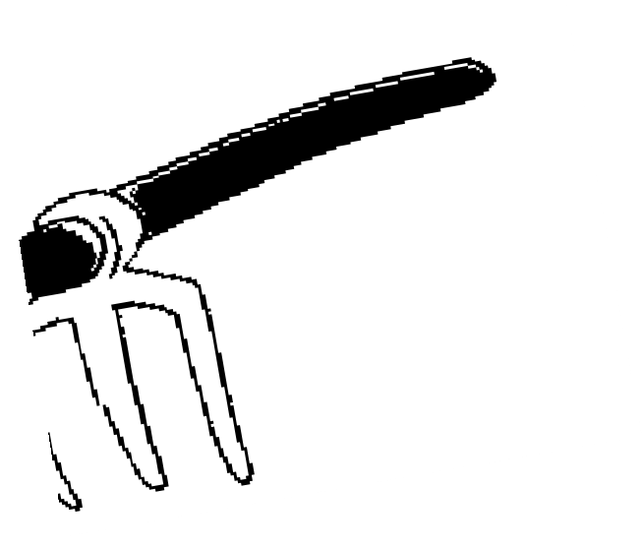Give any one way of caring for the above garden.
2. How does heat transfer by conduction useful in our daily life?
3. What is the importance of water in our environment?
4. Identify one type of immunity.
5. State one danger of floods in our environment.
6. Mention one reason for eating food.
7. Name one breed of rabbits.
8. Identify one living component of soil.
9. How do moulds feed?
10. Give one use of a stretcher in giving first aid.
11. Why should we drain all stagnant water in our homes?
12. Identify any one man-made change in the environment.
13. Apart from meat production, give any other reason of keeping domestic birds at home.
14. Name the body organ shown below.



1. Why is measles vaccine given to children at 9 months?
2. Of what use is smoke during harvesting of honey?

# SECTION B:

1. a) Give two reasons why people rear rabbits.
2. Name two diseases that affect both rabbits and fowls.
3. a) Name the instrument used by doctors to see germs.
4. Give any two bacterial diseases.
5. State one danger of bacteria to people.

# Use the diagram below to answer questions that follow.

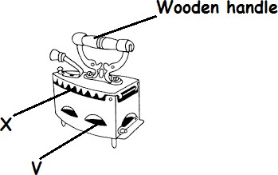

1. Why is the handle made of wood?
2. State the function of the part marked X?
3. Which part of the house is similar to the part marked V on the diagram?
4. a) State any one role of enzymes in the body.
5. Mention one condition under which enzymes work?
6. Name any two enzymes found in the stomach.
7. a) What are stem tubers?
8. Give two ways of caring for tuber crops.
9. Identify one example of a tuber crop.
10. a) Why is water called a universal solvent?
11. Give any other one example of a solvent apart from water.
12. What happens to salt when put in water and stir?
13. Mention one way of separating water mixed with salt.

# Match the deficiency diseases to the food value lacked Deficiency disease Food value lacked

* 1. Kwashiorkor - Vitamin B3
  2. Scurvy - Vitamin D
  3. Rickets - Proteins
  4. Pellagra - Vitamin C

1. Kwashiorkor :
2. Scurvy :
3. Rickets :
4. Pellagra :

# Study the diagram below and answer the questions that follow.

1. 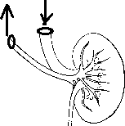Name the internal body organ shown above.
2. Identify one disease that affect the above body organ.
3. State two ways of caring for the above body organ.
4. a) Mention two uses of insects to people.
5. Give one way termites are dangerous to crop farmers.
6. How does a wasp protect itself?
7. a) Define soil erosion?
8. State two ways of preventing soil erosion in the garden.
9. How does bush burning cause soil erosion?

|  |  |  |  |
| --- | --- | --- | --- |
| 51. **Study the table below and fill in the missing information.** | | | |
|  | **Immunisable diseases** | **Vaccine** | **Site of body** |
|  | DPT |  |
|  | BCG | Right upper arm |
| Polio |  | Mouth |
| 1. a) What do the following parts of a seed develop into after fertilization?    1. Plumule    2. Radicle 2. Give one condition necessary for a seed to germinate. 3. Identify any one type of germination. 4. a) What are poultry vices?    1. Mention two ways of controlling poultry vices.    2. Name one example of a poultry vice. | | | |

# Use the diagram below to answer questions that follow.

* 1. Name the tool above.
  2. Identify the importance of the tool named in (a) above.
  3. Mention any two items kept in the above tool.

1. a) Name the method of finding the volume of a sweet potato tuber.
2. Mention one example of a regular object.
3. Calculate the density of an object whose weight is 40g and volume of 5cc **(2 marks)**

|  |
| --- |
| **PAPER 13** |
| **SECTION A**   1. Name the type of chicken reared for both meat and egg production. 2. Give **one** immunisable disease caused by a virus. 3. State **one** reason why people keep rabbits. 4. Write down **one** element of weather. 5. Mention **one** process by which soil is formed. 6. Name **one** type of fracture.   **Use the diagram below of a tooth to answer the questions 7 and 8.**     1. Name the type of tooth shown above. 2. What is the function of the above tooth? 3. State **one** way through which vectors spread diseases. 4. Of what importance are bees to plants? 5. Which method do we use to find the volume of a stone? |

1. Where does digestion of food end in man?



1. Name **one** state of matter.
2. Give **one** example of a root tuber grown in Uganda.
3. Name the garden tool shown below.
4. What is the use of the garden tool above?
5. Which worms enter our bodies through eating raw meat? (pork)
6. Mention **one** place where bacteria are found.
7. What is the normal body temperature of a person?
8. Name the crop commonly attacked by cassava mosaic virus?
9. Give **one** disorder of the digestive system.
10. Why does a piece of paper flat on water?
11. A sample of oil has mass of 160g. Its volume is 20cc. calculate its density.
12. Name the poultry used for commercial purposes.
13. What are communicable diseases?
14. Give **one** condition necessary for seed germination.
15. Name any **one** game played using air.
16. Define the term mulching as used in farming.
17. Mention **one** important process involved in rainfall formation.
18. What is sanitation?
19. Name the vector that spreads malaria fever to man?
20. Give **one** example of an annual crop.
21. State **one** agent of soil erosion.
22. Write down **one** property of matter.
23. Give **one** source of heat to the environment.
24. Name **one** by-product got from bees.
25. Name the body organ used to pump blood to all body parts.
26. Which component of air occupied 21% of the atmosphere?

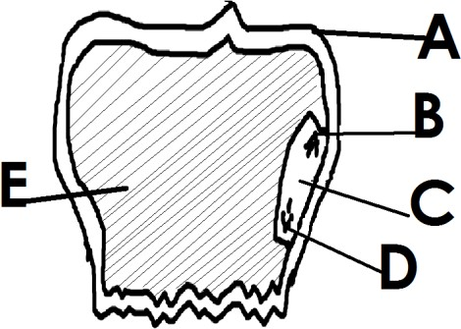

1. Why do we iron our clothes?
2. Give the main function of a leaf to a plant.

# SECTION B

1. a) What is energy?
2. Give any **one** type of energy.
3. What type of energy is possessed by water in a cup?

_

1. Apart from heat energy, name any one other form of energy.
2. a) Give any **one** example of a root tuber.
3. Name the root tuber grown by means of seeds.
4. State **one** reason why farmers weed their crops.
5. What is a crop pest?

# Use the diagram below of a maize grain and answer the questions that follow.

* 1. Name the parts marked:

A: C

* 1. State the function of the parts labelled:



B E

# Match the items in list A with those in List B correctly.

|  |  |
| --- | --- |
| A  Lack of carbohydrates Lack of vitamin D  Lack of iodine.  Lack of proteins | B  Kwashiorkor Scurvy Marasmus  Goiter |

1. Lack of carbohydrates :
2. Lack of vitamin D :
3. Lack of iodine :
4. Lack of proteins :
5. a) Name **one** disease that attacks both rabbits and poultry.
6. Give **two** examples of exotic breeds of rabbits.
7. How do we call the keeping of rabbits in many hutches in one place?

# The diagram below shows a water cycle. Use it to answer the following questions.

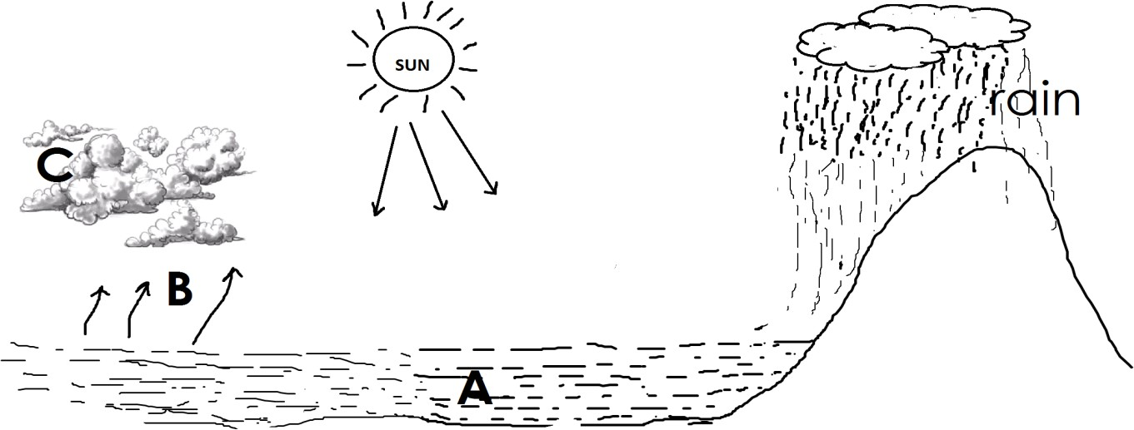

* 1. Which process takes place in:

A : C :

* 1. Name the substance marked B.
  2. State the importance of the sun in the water cycle.

1. a) State the importance of keeping poultry.
   1. What is the use of the chalaza in an egg?
   2. Name the poultry system commonly used by most farmers in rural areas.
   3. Which poultry vice is controlled by most farmers in rural areas.
2. a) How does heat travel through:
3. solids :
4. liquids :
5. gases :

b) Name the instrument which is used to keep hot things hot and cold things cold.

1. a) How are babies protected against measles?
2. Name two childhood immunisable diseases immunized at birth?

i) ii)

1. Which immunisable disease enters the body through fresh cuts and wounds?

# The diagram below shows some of the parts of the digestive system. Sue it to answer the questions that follow.

|  |  |
| --- | --- |
|  | 1. Name the parts marked:   A B D   1. State one disease that attacks the above system. |

1. a) Give any **one** example of each of the following:
2. Solute :
3. Solvent :

b) How can each of the following be separated?

1. Salt from water :
2. Stones from beans :
3. a) Name the **two** sets of teeth.

i) ii)

b) Mention **two** types of teeth.

3. a) Write down **two** causes of road traffic accidents in Uganda.



1. Define the term First Aid.
2. Give **one** example of common accidents at home.

# Use the diagram below to answer the questions that follow.

|  |  |
| --- | --- |
|  | 1. Which part of a flower is shown in the diagram?   _   1. Name the part marked A.   _   1. What does part marked X and Y become after fertilization? |

1. a) What is matter?
   1. Mention **one** source of heat.
   2. Change 250C to 0F

|  |
| --- |
| **PAPER 14** |
| **SECTION A**   1. Name **one** example of a flowering plant. 2. Name the gas needed for seed germination. 3. Why should a hutch be built some meters above the ground? 4. Name the First Aid equipment below.      1. State the importance of the above equipment in Fist Aid. 2. How do farmers control crop pests in the garden? 3. Name any **one** type of poultry. 4. Give any **one** example of a root tuber. 5. How is the morning sunlight important to our bodies? 6. Why do farmers mulch their vegetable gardens? 7. How is chlorophyll useful to plants during photosynthesis? 8. Give any **one** reason why animals move from one place to another. 9. State any **one** cause of traffic accidents on roads. |

1. Give any **one** way a person can get infected by intestinal worms.
2. In the space below, draw a garden tool used for watering crops.
3. State the importance of a fire extinguisher in a school.
4. Why are petals of a flower brightly coloured?
5. In which **one** way can a P.4 pupil maintain oral health?
6. State the function of the human brain.
7. Give any **one** example of crop pests.
8. State any **one** importance of farm records on a farm.
9. Why is typhoid called a communicable disease?
10. Name the food value obtained from eating sugarcanes.
11. Why is any eggshell porous?
12. State any **one** function of feathers to birds.
13. Name the property of air shown below.

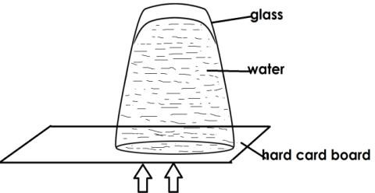

1. What do arrows show in the experiment above?
2. Name any **one** source of proteins.
3. State the deficiency disease one gets due to lack of vitamin D in the body.
4. Name any **one** exotic breed of poultry kept for laying eggs.
5. What do hookworms feed on in the body?
6. Name the special food given to queen bees.
7. Why does a chameleon change color according to its environment?
8. State the importance of keeping a latrine clean.
9. How is transpiration important to plants?
10. How is a burn different from a scald?
11. Name the component of air with the least percentage in the atmosphere.
12. State any **one** importance of wind to people.

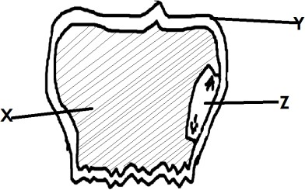

1. What name is given to a female part of a flower?
2. Why is loam soil the best for growing crops?

**SECTION B**

1. a) What is food preservation?
   * 1. Name any **two** methods used to preserve food.
     2. How does smoking help to preserve food?
2. a) Who is a casualty?
3. Give **two** reasons why we give First Aid.
4. Give a reason why a first aider should be quick in giving First Aid.
5. a) Name **two** body organs protected by the ribcage.

b) Give any **two** ways we can keep the proper functioning of our skin.

# Below is a grain. Use it to answer questions that follow.

* 1. Name part marked **Y**.

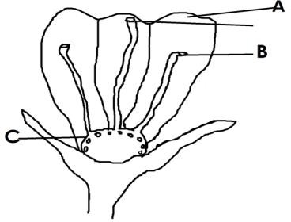

* 1. State the function of part marked **X**.
  2. Name any **one** part of the above grain that makes up its embryo.
  3. State any **one** use of the above grain to people.

1. a) Give any **one** reason why some people rear rabbits.
2. Name any **one** exotic breed of rabbits reared in Uganda.
3. Identify any **one** disease of rabbits that can also affect poultry.
4. How can diseases on a rabbit farm be prevented?
5. a) What is personal hygiene?

# _

1. Give **two** reasons why it is important to spread beddings under sunshine.
2. How is soap useful in promoting personal hygiene?

# The diagram below shows parts of a flower. Use it to answer questions that follow.

* 1. Name part marked A.
  2. State the importance of part marked B.



* 1. What does part C develop into after fertilization?
  2. Give any **one** importance of flowers to people.

1. a) Give any **two** examples of intestinal worms.
2. State any **one** danger of intestinal worms.
3. How can intestinal worms be prevented in children?
4. a) What are communicable diseases?
5. Give any **two** examples of communicable diseases.
6. Give any **one** way communicable diseases can be spread from one person to another.
7. a) Name any **two** types of bees.

10. Name the type of bees commonly seen around flowers.
11. How do bees protect themselves from enemies?

# The diagram below shows a practice carried out in poultry. Use it to answer questions that follow.

* 1. Name the practice shown above.



* 1. Why do farmers carry out such a practice?
  2. What name is given to chickens reared for:
     1. Egg production:
     2. Meat production:

1. a) State **one** difference between air and wind.

b) How are the following components of air important in our environment?

1. Oxygen:
2. Carbon dioxide:
3. a) Write ORS in full.
4. Name any **one** solute used to make ORS.
5. How important is washing hands during preparation of ORS?
6. Why should a dehydrated person be given ORS?
7. a) What is a fracture?
8. Name any **one** type of fracture.
9. How important are splints during giving First Aid to a fractured arm.
10. State any **one** sign of fractures in children.

|  |  |
| --- | --- |
| **Match items in List A wi LIST A**  tsetse fly infected dog water snail  cockroach | **th those in List B.**  **LIST B**  bilharzia typhoid  sleeping sickness  rabies |

Tsetse fly: Infected dog: Water snail: Cockroach:

For more Booklets of this kind, Visit [www.tekartlearning .com](http://www.tekartlearning.com/) or call +256754895241